Weight Training & Physical Conditioning 25-26 Semester 1 Daily Assignments/Activities
Tuesday August 5, 2025
- Review of expectation (coaches)
- Static & Dynamic Stretching & Walk
Wednesday August 6
- Review of expectation (coaches)
- Static & Dynamic Stretching & Walk
- Muscle review during stretch
Thursday August 7

Muscle Handout

Name: Date: ____Period:

Instructions: Make sure to write your name, date and class period
- Label the following muscles on the diagram provided; Use the word bank below to identify each muscle.
- Write the name of the muscle next to the correct number on the diagram.
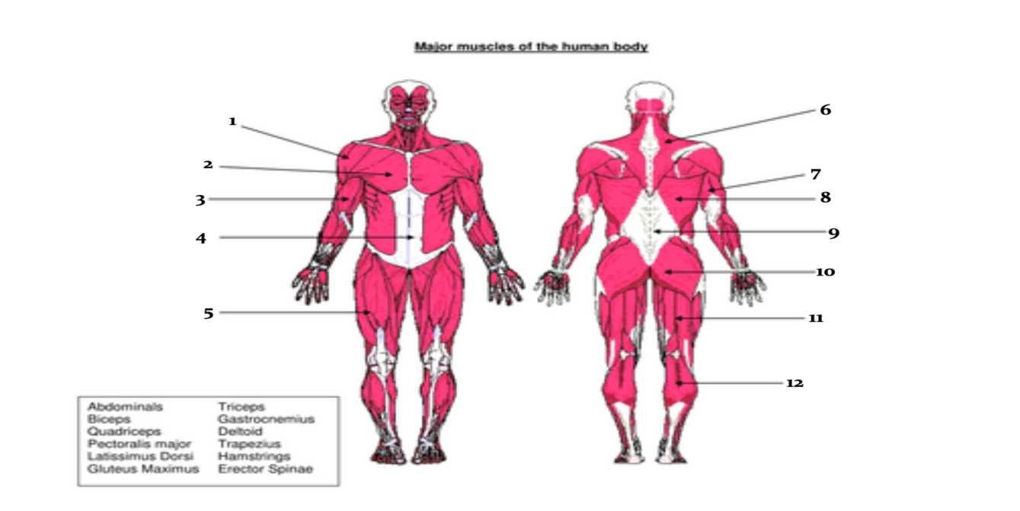
Word Bank (Common Names)

- Abdominals
- Biceps
- Quadriceps
- Pectoralis Major
- Latissimus Dorsi
- Gluteus Maximus

- Triceps
- Gastrocnemius
- Deltoid
- Trapezius
- Hamstrings
- Erector Spinae

- Muscle video: https://www.youtube.com/watch?v=z7psWfRLXFY
Friday August 8
Muscles Review on quizziz

